Born to Play (Ages 3-4) This is a Co-Ed class that introduces your player to baseball in a fun teaching environment.
Saturday’s 10:00am-10:50am 4 weeks for $80
Age based skills classes focusing on the Big Four: hitting, throwing, fielding and catching.

Rookie Class (Ages 5-6) Saturday’s 11am-12pm
Minors Class (Ages 7-9) Saturday’s 12pm-1pm 4 weeks for $100
Majors Class (Ages 10-12) Saturday’s 1pm-2pm
Zach’s Pitching Camp Building clean and consistent mechanics with a proper warm up and recovery routine. Using data to create a competitive environment and improve skills.

Tuesday’s 6:00pm-7:00pm (Ages 8-12) 4 weeks for $100
Thursday’s 6:00pm-7:00pm (Ages 13-18)
Catchers Clinic (Ages 8-16) A class just for catchers. Improve your receiving, blocking, and throw downs.

Wednesday’s 5:00pm-6:00pm 4 weeks for $100
Hitting Boot Camp A baseball only hitting class that teaches situations, bat speed, strength, visual mechanics, contact angles and lots of reps. Quick moving stations to give you different looks and drills to improve!

Thursday’s 6:00pm-7:00pm (Ages 8-12) 4 weeks for $100
Thursday’s 7:00pm-8:00pm (Ages 13+)
World Membership: A Family Membership that saves you money and gives you free training time.You will receive discounts on all lessons, rentals, classes, clinics and camps. Valid for 1 year from the purchase date.

- Family membership: $300 annual fee. Includes 12 (1/2 hour) cage rentals and 2 free 30 minute lessons.
- Save 20% on all lessons, rentals, camp and clinics along with 10% on all pro-shop purchases.
Facility and Cage Rentals: Rent one of our cages and work on hitting, pitching, or fielding! Cages are available by reservation only.
$50 Per Hour
Private Lessons (Ages 5+) Individual lessons are available by appointment.
30 min= $45 60 min= $85
5 pack (30 min)= $210 15 pack (30 min)= $600
10 pack (30 min)= $410 20 pack (30 min)= $780

Frozen Ropes Albany
3 Interstate Ave. Albany, NY 12205 (518) 435-2424
www.frozenropes.com/albany

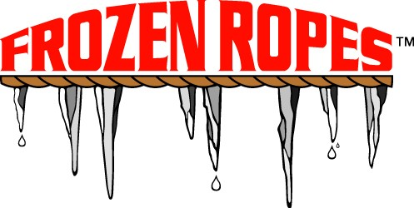 2021 SPRING BASEBALL SOE
APRIL 1st - MAY 31st

